**Course Five**

# Regression Analysis: Simplifying Complex Data Relationships

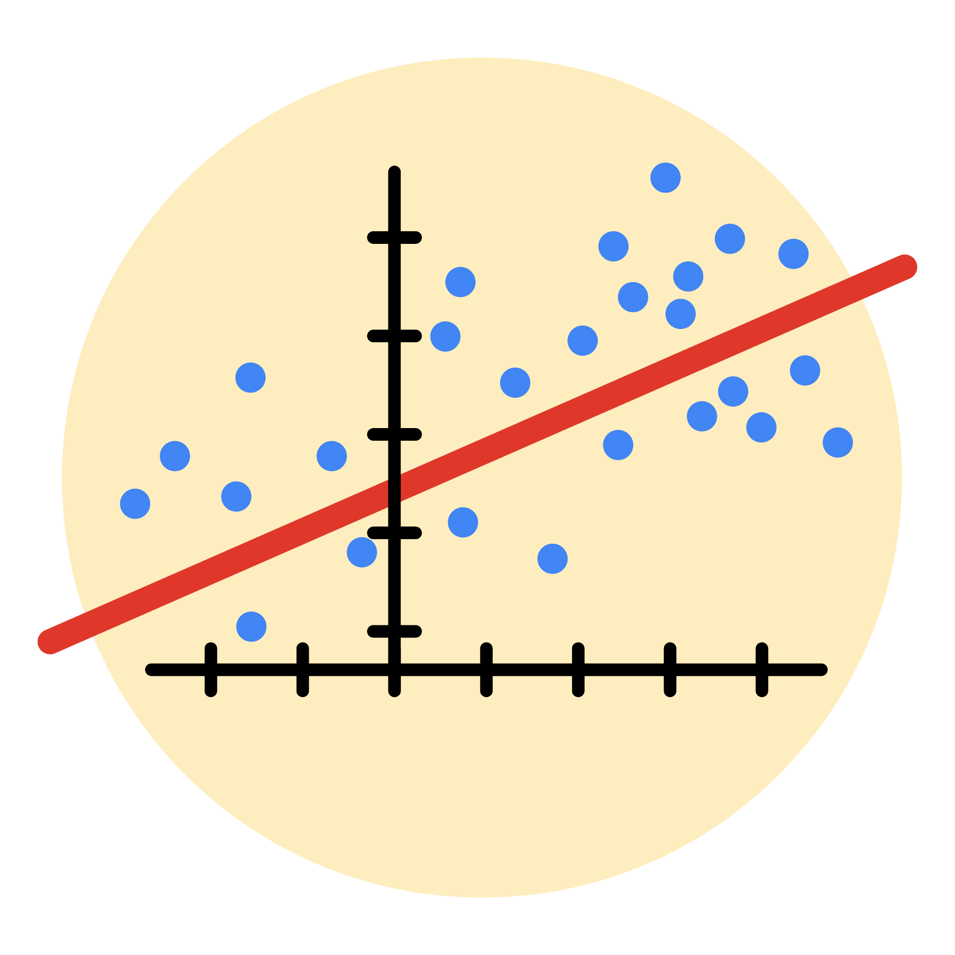

# Instructions

Use this PACE strategy document to record decisions and reflections as you work through this end-of-course project. As a reminder, this document is a resource that you can reference in the future, and a guide to help you consider responses and reflections posed at various points throughout projects.

# Course Project Recap

Regardless of which track you have chosen to complete, your goals for this project are:

* ~~Complete the questions in the Course 5 PACE strategy document~~
* ~~Answer the questions in the Jupyter notebook project file~~
* ~~Build a multiple linear regression model~~
* ~~Evaluate the model~~
* ~~Create an executive summary for team members~~

# Relevant Interview Questions

Completing the end-of-course project will empower you to respond to the following interview topics:

* Describe the steps you would take to run a regression-based analysis
* List and describe the critical [assumptions of linear regression](https://www.digitalvidya.com/blog/assumptions-of-linear-regression/)
* What is the primary difference between R2 and adjusted R2?
* How do you interpret a Q-Q plot in a linear regression model?
* What is the bias-variance tradeoff? How does it relate to building a multiple linear regression model? Consider variable selection and adjusted R2.

**Reference Guide**

This project has seven tasks; the visual below identifies how the stages of PACE are incorporated across those tasks.

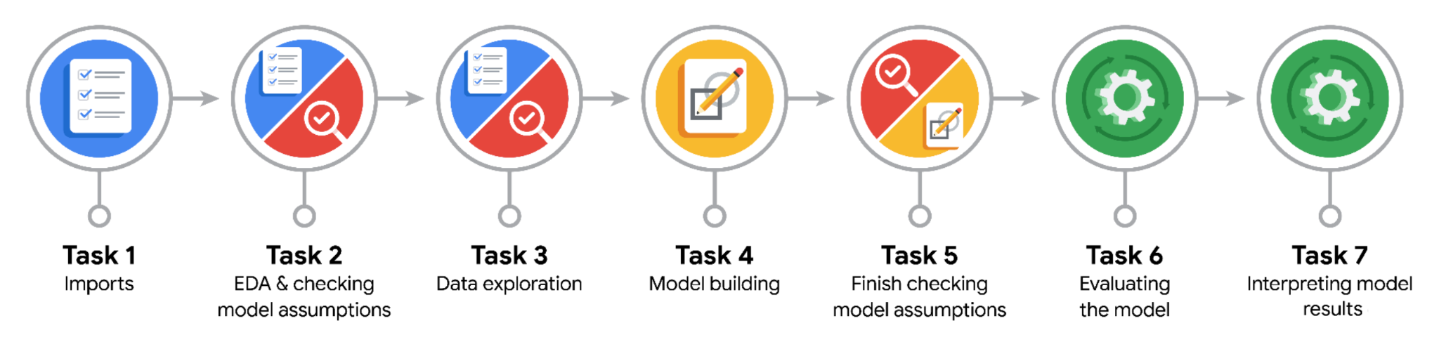

**Data Project Questions & Considerations**

**PACE: Plan Stage**

* Who are your external stakeholders for this project?

TikTok.

* What are you trying to solve or accomplish?

Conduct a logistic regression using verified status as the outcome variable.

* What are your initial observations when you explore the data?

93.71% of the dataset represents videos posted by unverified accounts and 6.28% represents videos posted by verified accounts. So the outcome variable is not very balanced.

* What resources do you find yourself using as you complete this stage?

Packages for data manipulation.  
Packages for data visualization.

**PACE: Analyze Stage**

* What are some purposes of EDA before constructing a multiple linear regression model?

Identify outliers and extreme value that can impact model.

* Do you have any ethical considerations in this stage?

Identify outliers and extreme value that can impact model.

**PACE: Construct Stage**

* Do you notice anything odd?

Each additional second of the video is associated with 0.01 increase in the log-odds of the user having a verified status.

* Can you improve it? Is there anything you would change about the model?

No. The model already decent predictive power (67% precision and 65% recall).

* What resources do you find yourself using as you complete this stage?

Packages for data preprocessing.  
Packages for data modeling.

**PACE: Execute Stage**

* What key insights emerged from your model(s)?

Each additional second of the video is associated with 0.01 increase in the log-odds of the user having a verified status.

* What business recommendations do you propose based on the models built?

Construct a classification model that will predict the status of claims made by users.

* To interpret model results, why is it important to interpret the beta coefficients?

Helps identify the values that are currently in use.

* What potential recommendations would you make?

Classify claims and opinions, it’s important to build a model that shows how to predict the behavior of the account type (verified) that tend to post more opinions.

* Do you think your model could be improved? Why or why not? How?

No. The model already decent predictive power (67% precision and 65% recall).

* Given what you know about the data and the models you were using, what other questions could you address for the team?

Need more data to improve confusion matrix result ?

* Do you have any ethical considerations at this stage?

Recommend based on finding or on model result.